DDC CODE DOWNLOADING PROCESS
The DDC programming is done at S-Wave Systems. The sequence followed in using the programming software is given below.
Connect one USB port of the PC to the DTCL USB through USB cable end terminated with Type C connectors
Connect another USB port to the STM32Cube programmer part no: ST-LINK/V2 through USB cable end terminated with Type c A connector on the PC side and Mini- B USB connector on the programmer side.
Connect the programmer output to the programming terminations on the DTCL

The connection diagram is shown in Figure 1
DTCL MAIN PCB J6 |  |  | ST-LINK/V2 J4
SIGNL NAME | PIN NO |  | SIGNL NAME | PIN NO
JTCK_SWCLK | 2 |  | SWCLK | 9
JTMS_SWDIO | 3 |  | SWDIO | 7
NRST | 4 |  | NRST | 15
GND | 5 |  | GND | 20,18

Indicate the connections on the berg pins on card
Locate STM32Cube programmer
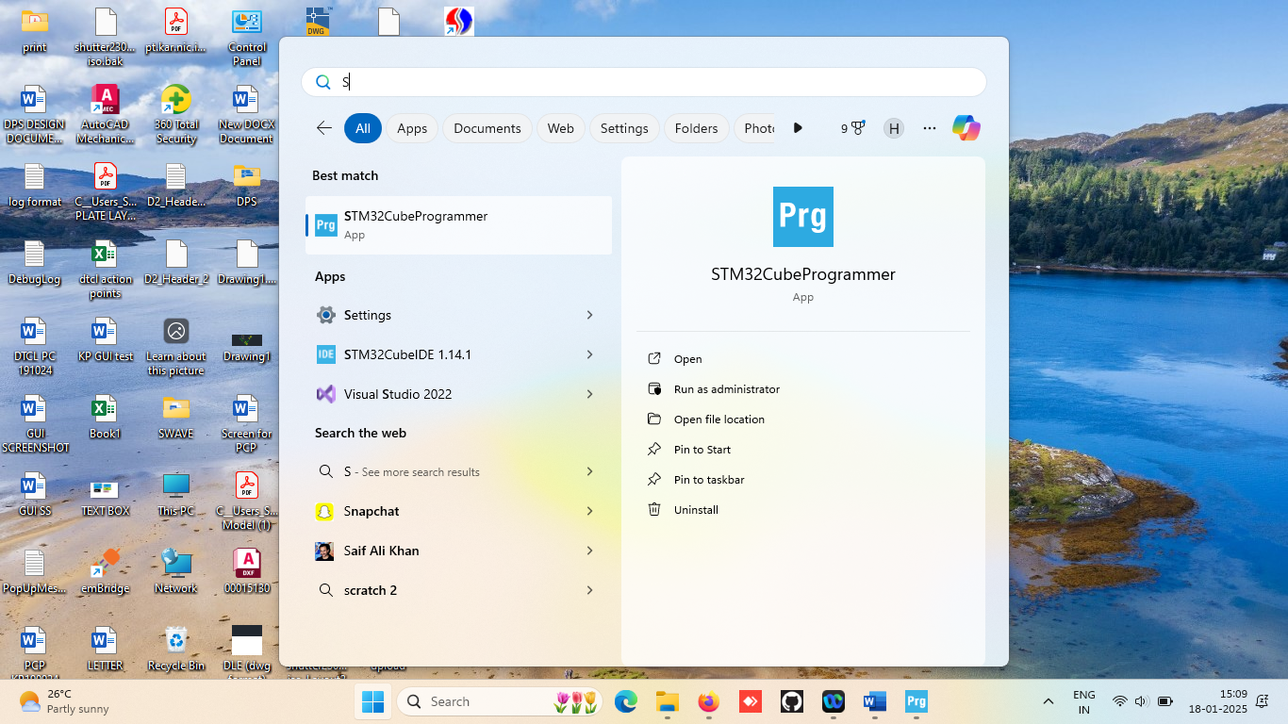
On selecting the following screen will appear
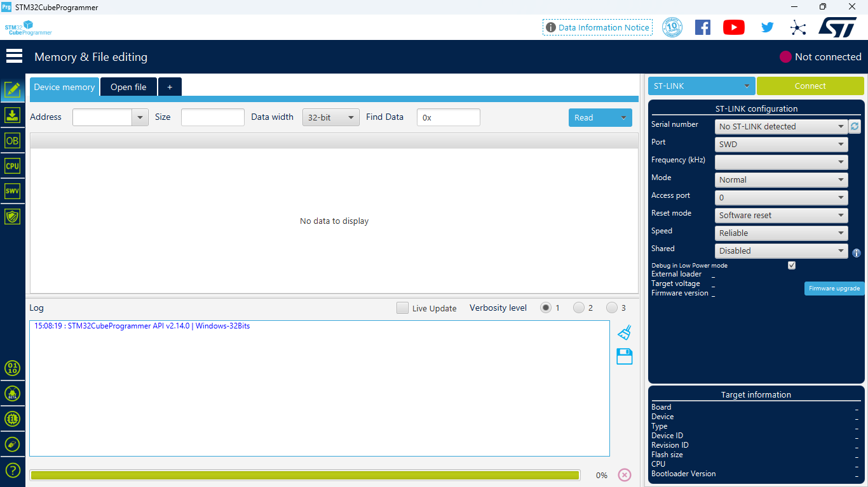
Under ST-LINK configuration, go to dropdown button “Shared”

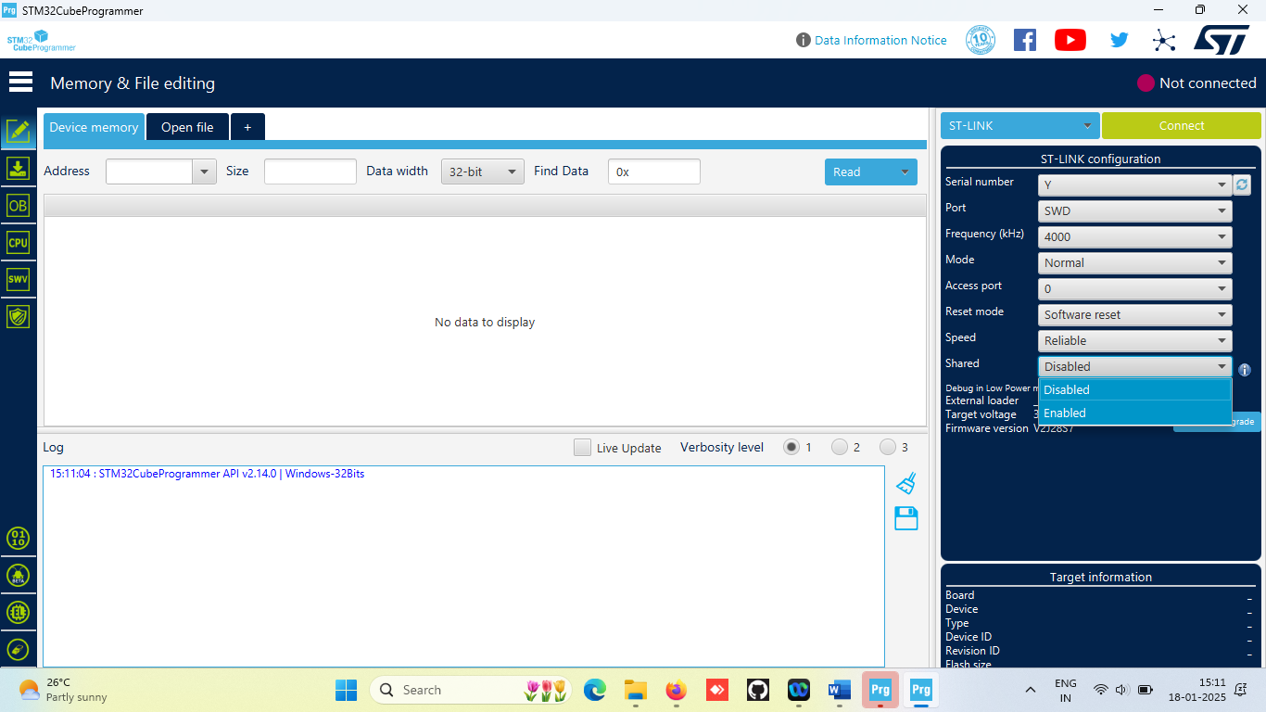
Under ST-LINK configuration, against “Shared” select enable,
Enabled will appear
Go to serial number and select the round arrow
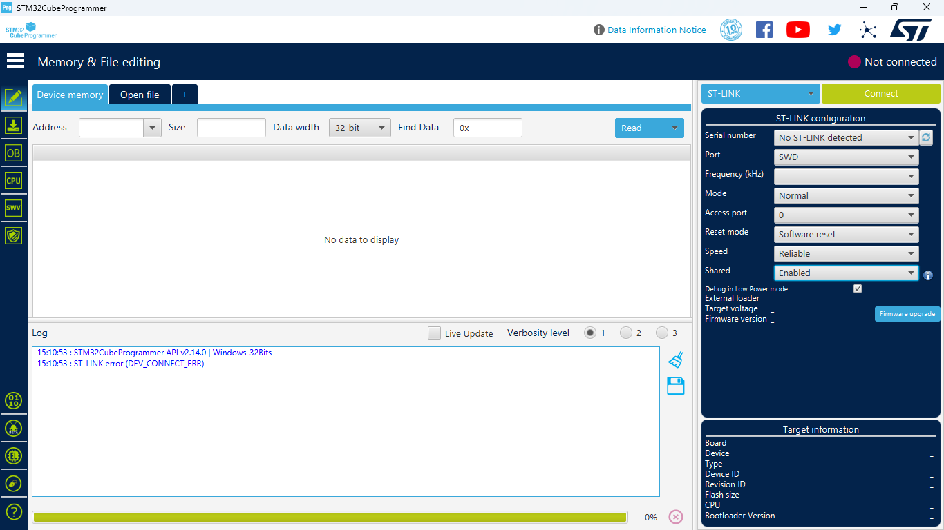
Serial number will appear as shown, select connect button

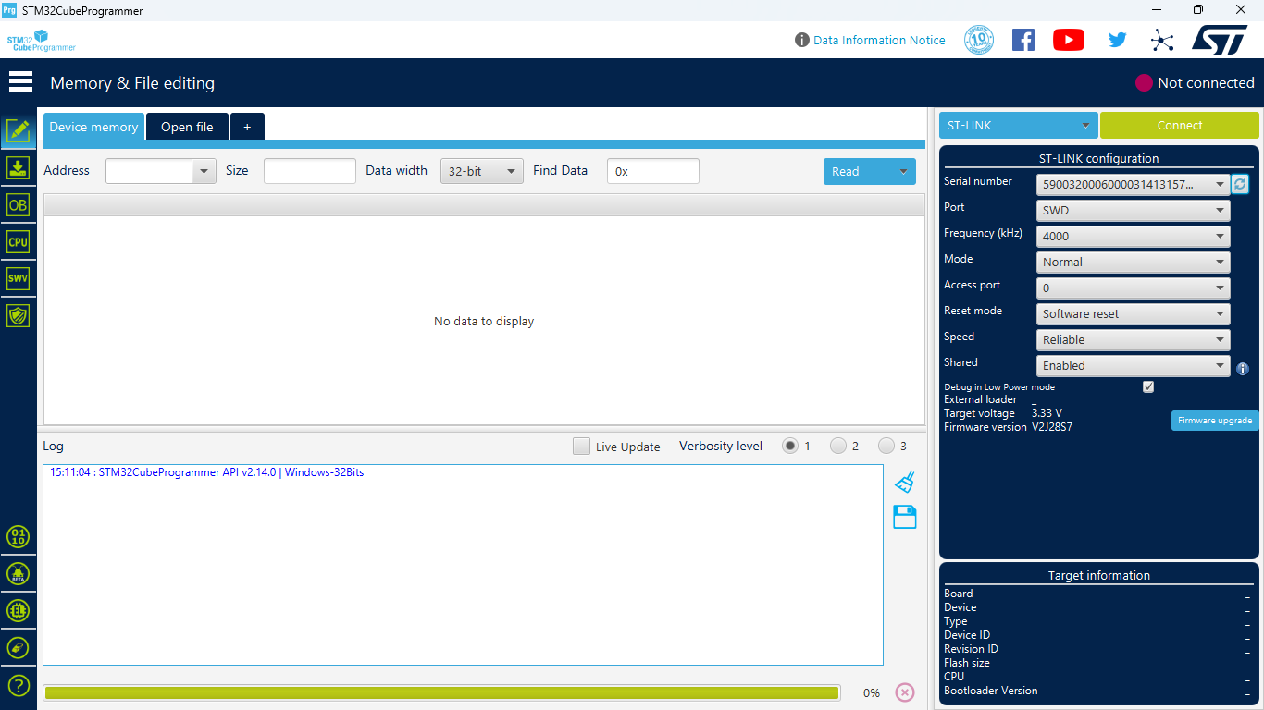
The connected state will appear as shown
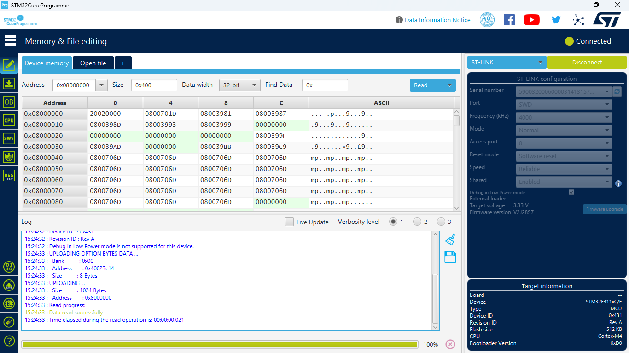
Select open file button
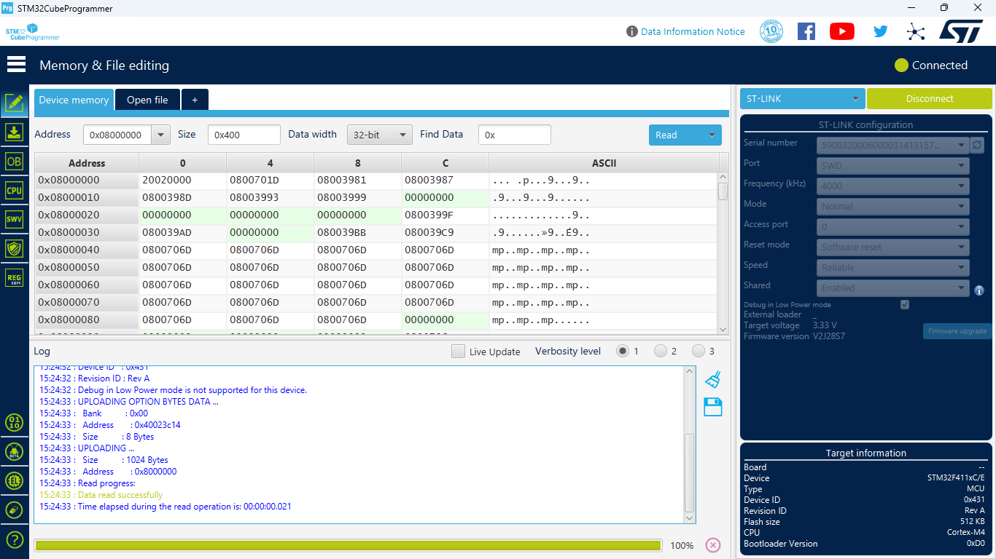

Browse DDC.elf file in the GUI installation path.
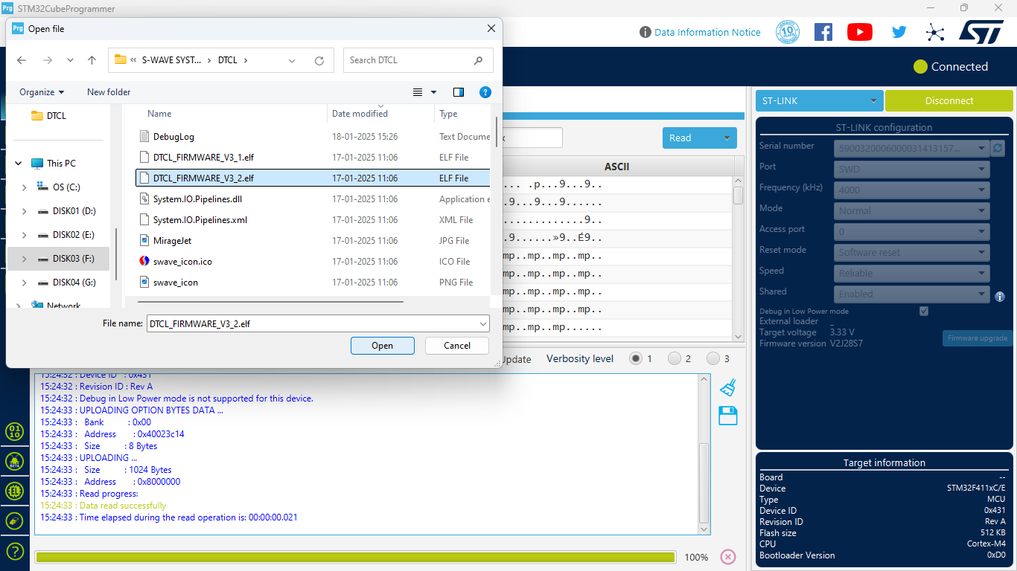
The browsed file will appear as shown, Select download button
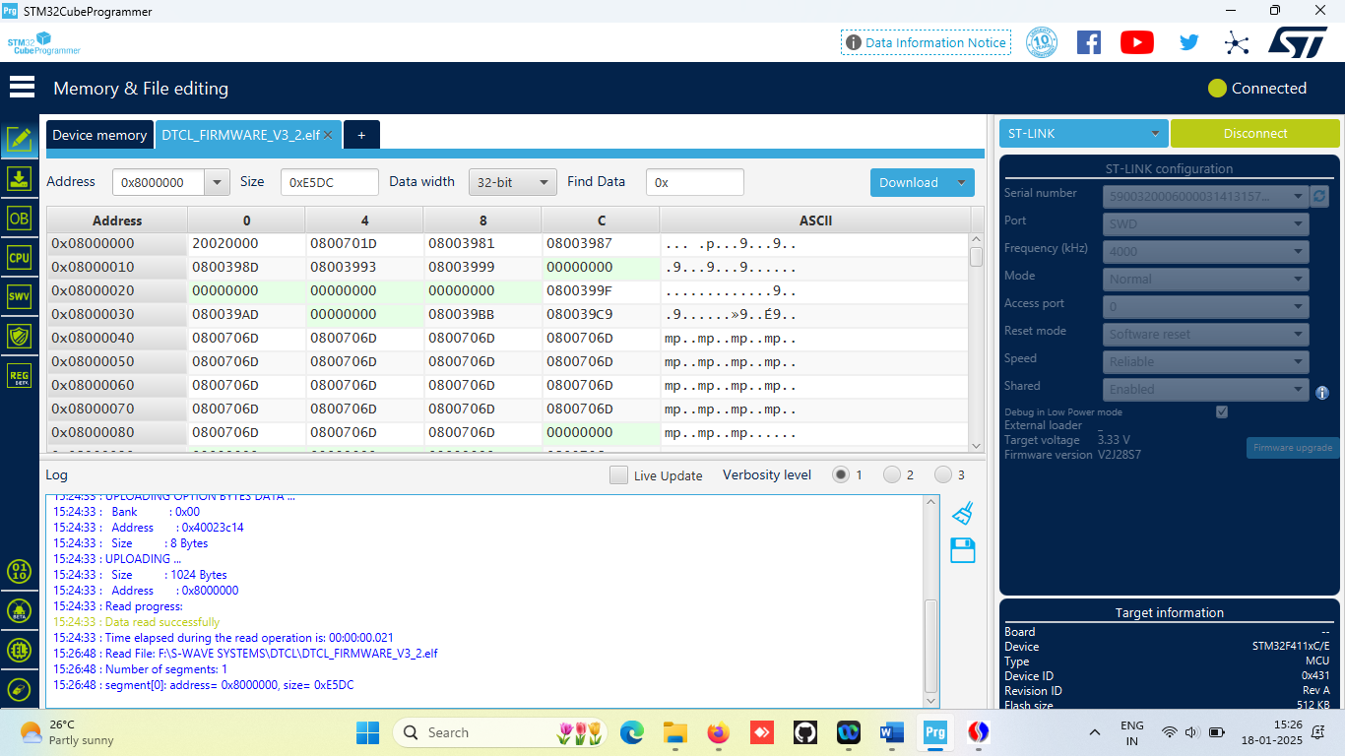

Download will get initiated
On completion of download pop window will appear indication “file download complete” Select disconnect

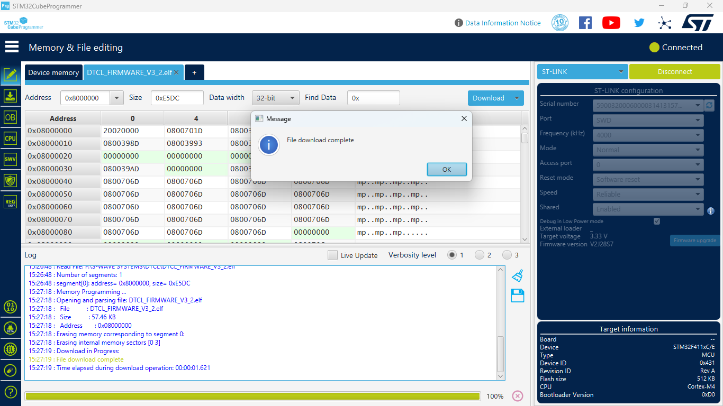
Removing programming connection from the DTCL.

